Specops Password Reset & Account Unlock

**Specops Self-Service Password Reset and Account Unlock** allows you to securely reset your password and unlock your account without IT assistance. This will ensure quick access when you need it without needing OHH IT intervention.

**Why Enrollment is Required:**

* All OHH **password resets** and **accounts unlocks** will now be directed to Specops Self-Service Password Reset.
* When calling the OHH Helpdesk, you will be verified with your Specops Self-Service Password Reset enrollment methods below.

Specops Enrollment - Step-by-Step Instructions

1. Start by clicking the link below to start the enrollment process.

<https://login.specopssoft.com/Authentication/Enroll?domainName=okheart.com>

1. Enter your OHH username.

*This is the username you use to log into OHH systems, not your email address.*

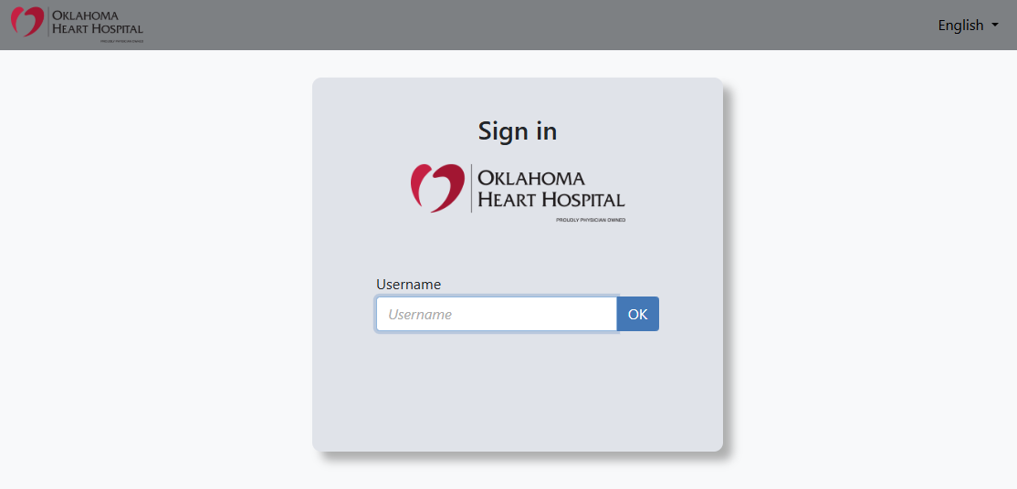

1. Then enter your OHH password.

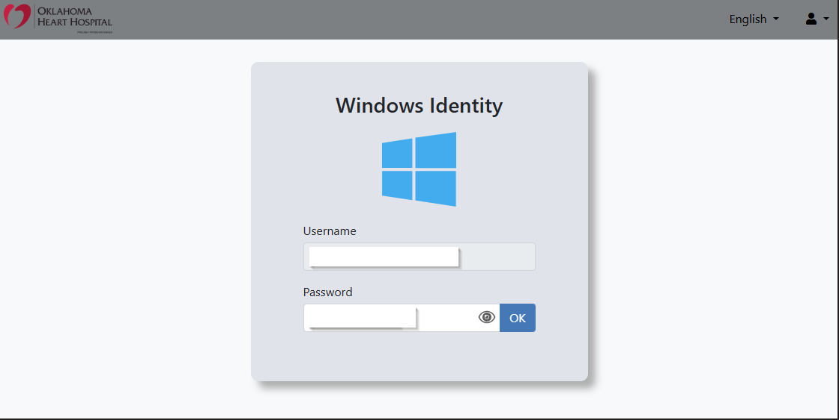

1. Continue to enroll with your personal email address and cell phone number. You will receive a code via SMS Text Message and Email to the phone number and email you provide.

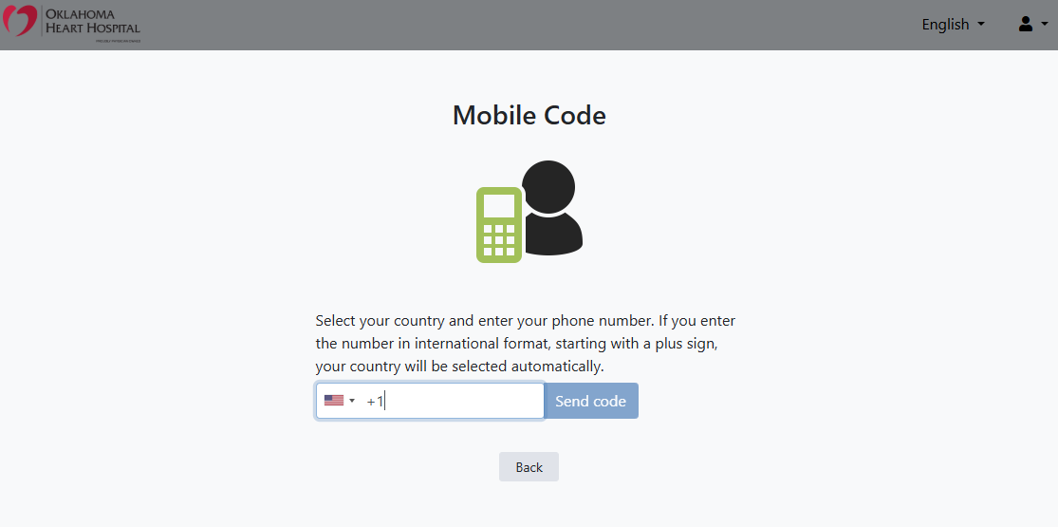

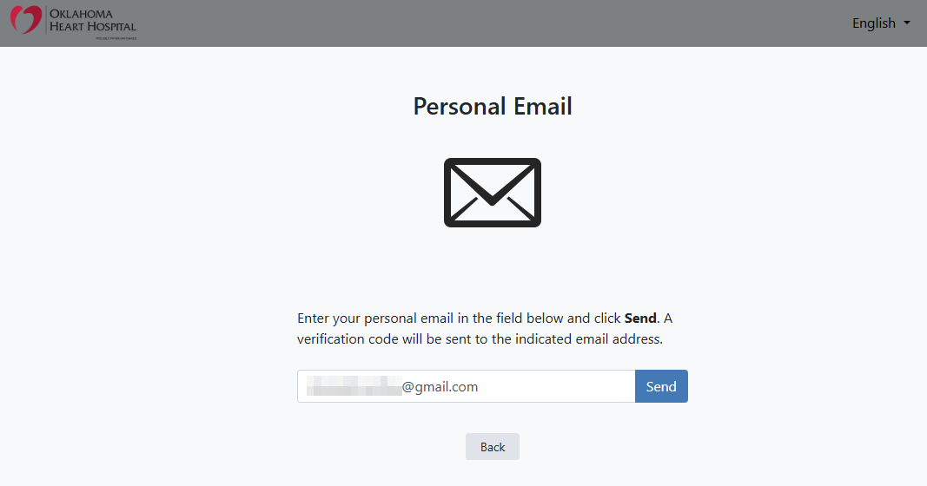

1. On the next screen, click the Microsoft Authenticator button (see image below)

*(This app is already required for your OHH Microsoft 365 Multifactor Authentication)*

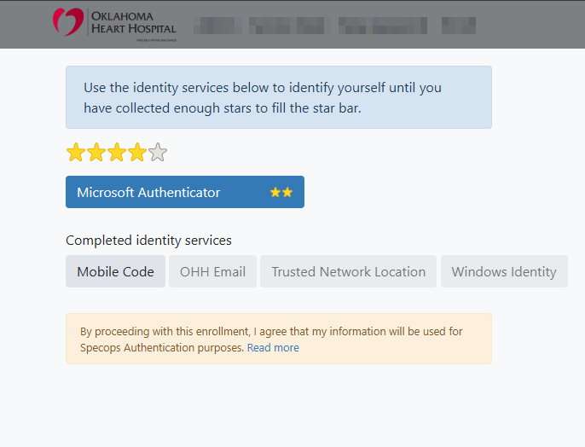

* 1. Apple iOS: [Microsoft Authenticator on the App Store](https://apps.apple.com/us/app/microsoft-authenticator/id983156458)

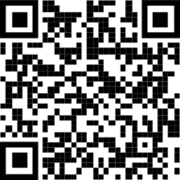

* 1. Google Play store: [Microsoft Authenticator - Apps on Google Play](https://play.google.com/store/apps/details?id=com.azure.authenticator)

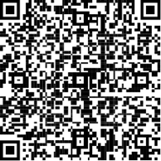

1. Follow the instructions on the page to enroll your Microsoft Authenticator App.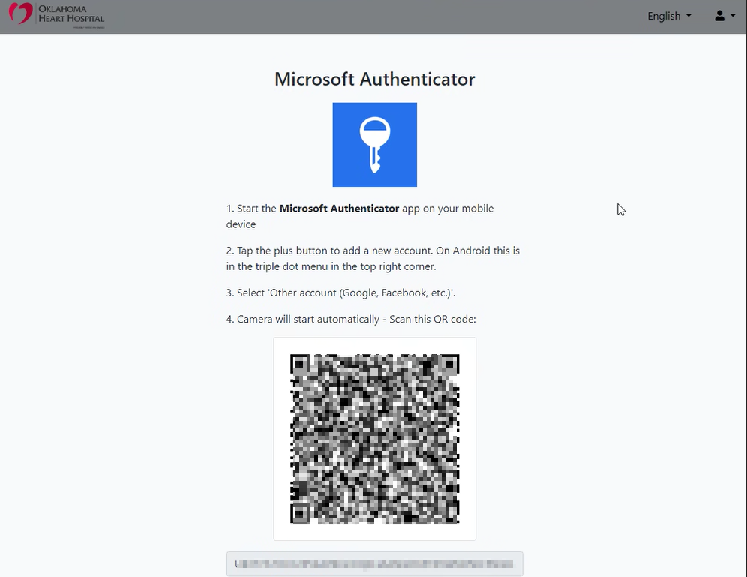
2. All Done! You can click “I’m Done” and close your browser window.

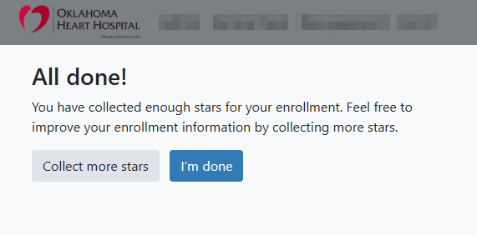

Using Specops

1. In the future, you can go to the link below to reset your password or unlock your account.

(The link is also available at <https://www.okheart.com/mis-support/>)

<https://login.specopssoft.com/Authentication/Password?domainName=okheart.com>

You will be authenticated by the methods you just enrolled in

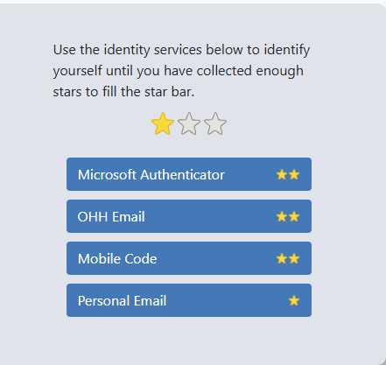

1. Click the appropriate identity services and collect enough stars to unlock or reset your account. After collecting the appropriate number of stars, you will be given the options below to help re-gain access to your account.A screenshot of a login page

   Description automatically generated